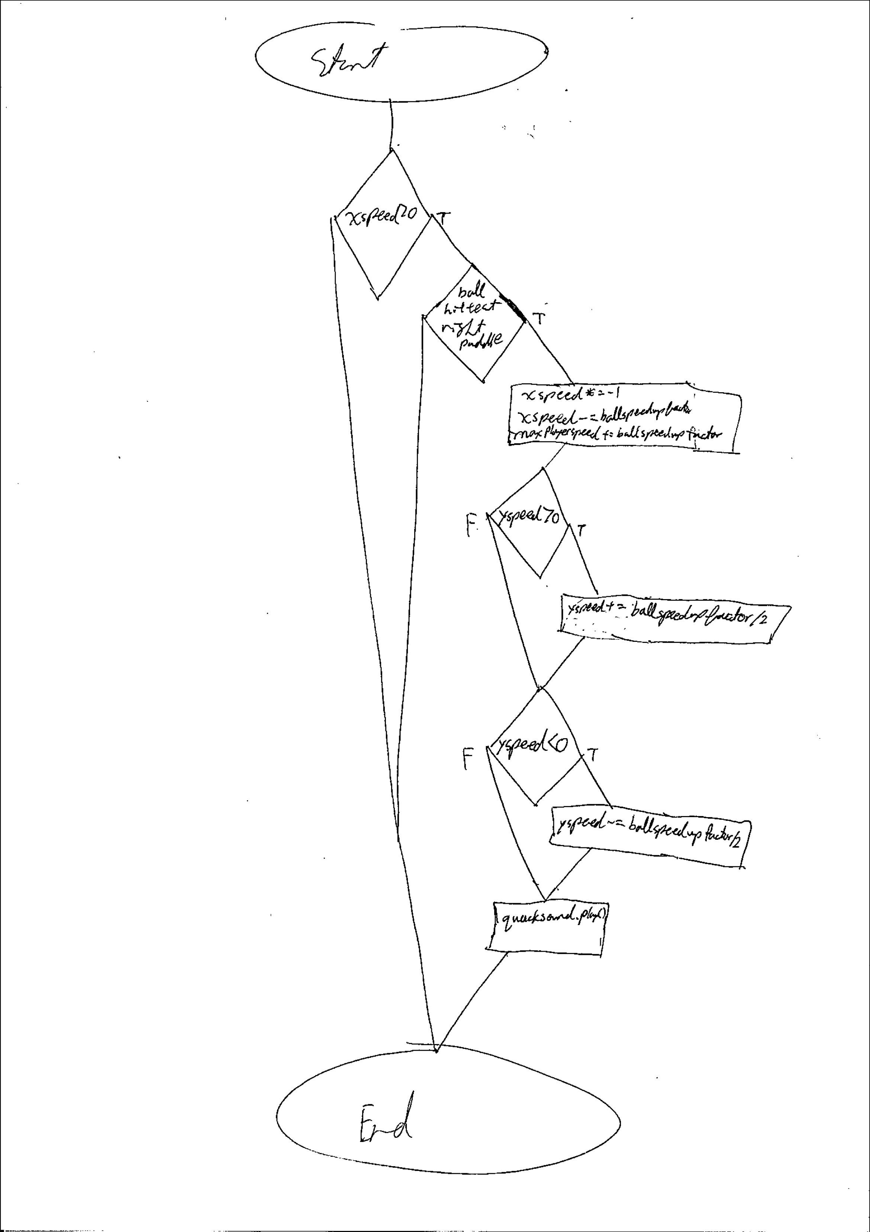

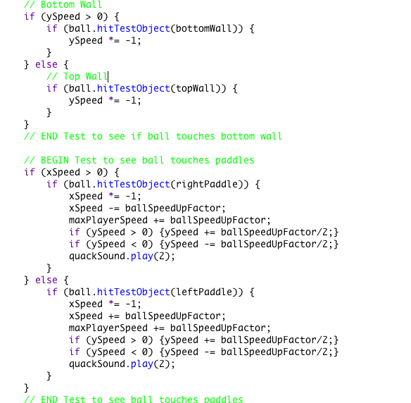

I chose to nest the right paddle hit test inside a binary selection, which only returns true when the ball’s xSpeed is greater than 0. This is important because it means that the hit test only happens when the ball is moving towards the right side of the screen. This fixes the glitch where the ball gets stuck in the paddle bouncing back and forth. THEN if the if statement which tests the right paddle hit test returns true, the data operator \*= -1 will reverse the direction which the ball if moving.

Pseudo Code

IF xSpeed > 0

THEN IF ball.hitTestObject(rightPaddle))

THEN xSpeed \*= -1;

xSpeed -= ballSpeedUpFactor;

maxPlayerSpeed += ballSpeedUpFactor

IF ySpeed > 0

THEN ySpeed += ballSpeedUpFactor/2;

END IF

IF ySpeed < 0

THEN ySpeed -= ballSpeedUpFactor/2;

END IF

PLAY QUACK SOUND

END IF

END IF

Add

Greater than

Binary Selection